Team 4: Chandler Stevens, David Ang, Jason Djajasasmita, and Matthew Paik

Second Progress Report

**User Interface**

A completed low-fidelity prototype may be viewed here: [WalletWatch Balsamiq Prototype.pdf](https://teams.microsoft.com/l/file/02CED7B7-B251-4AF0-8AAB-904AEF191138?tenantId=d7270324-ea10-47a1-ae5f-74dba073f8fd&fileType=pdf&objectUrl=https%3A%2F%2Fspuonline.sharepoint.com%2Fsites%2FCSC415xWS20202%2FShared%20Documents%2FTeam%204%2FWalletWatch%20Prototype.pdf&baseUrl=https%3A%2F%2Fspuonline.sharepoint.com%2Fsites%2FCSC415xWS20202&serviceName=teams&threadId=19:d636031255fd466f8aa323a89c54a6db@thread.skype&groupId=1128cb48-882f-4a74-b1f0-1db1209be26d)

The system architecture for “Tab 1: Add Entry” will be supported by the following interface:

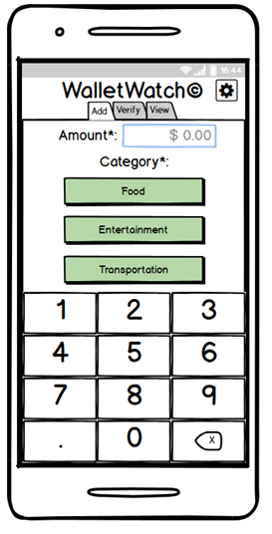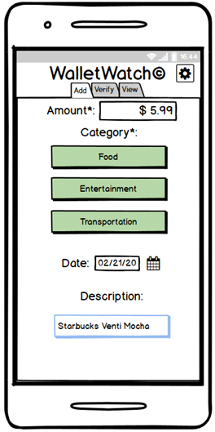

Upon launch, the app will display the screen on the left, which will allow the user to immediately start entering the dollar amount of the expense. After entering an amount, the user can close the numpad, thus displaying the screen on the right, and optionally provide a different date in the past and/or a brief description of the purchase. The user taps one of the three categories to add the entry. The user may then continue to enter additional entries or to proceed to a different tab, which begins by asking for the user’s PIN.

The system architecture for “PIN Verification” will be supported by the following interface:

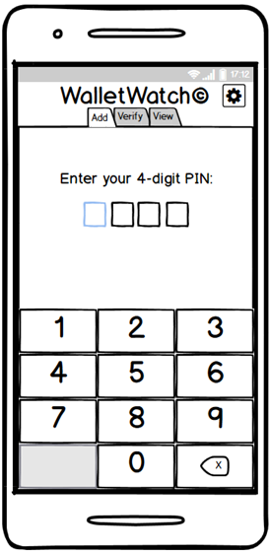

Upon entering all 4 digits correctly, this screen overlay will close and proceed to the requested tab.

The system architecture for “Tab 2: Verify Entries” will be supported by the following interface:

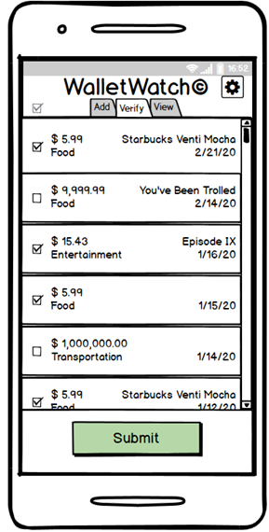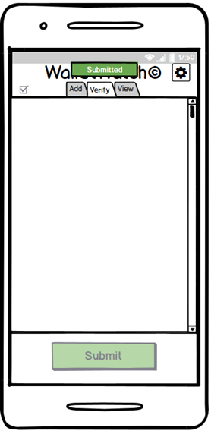

The left screen displays all added entries that have not yet been submitted as verified. The user may tap the top-left checkbox to select all the entry checkboxes in the queue, which will all be checked by default. The user may deselect certain entries deemed erroneous before tapping the “Submit” button to actually save the entries into the local data repository, which then clears the queue and displays the screen on the right.

The system architecture for “Tab 3: View Analytics” will be supported by the following interface:

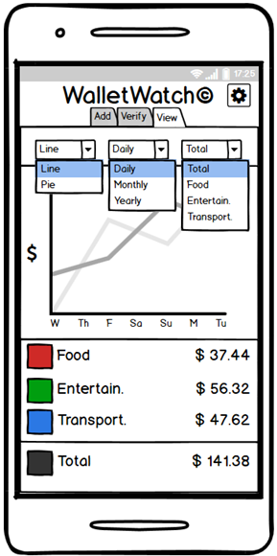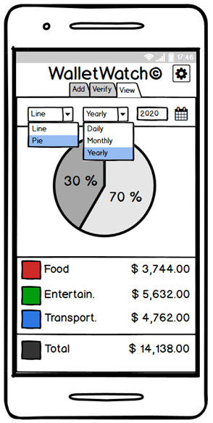

The left screen shows the line chart and the right screen displays the pie chart, which can be selected from the left combo-box. The middle combo-box allows the user to specify the time interval filter, which will change the x-axis on the line chart. The right combo-box on the line chart view allows the user to select which line to display from either a total aggregation or of a single category. The right date-selector on the pie chart view allows the user to select a specific time based on which time interval they selected in the middle combo-box. Below the charts, the total aggregated dollar amounts of all expenses that match the selected filters is displayed for quick reference.

The system architecture for “Settings” will be supported by the following interface:

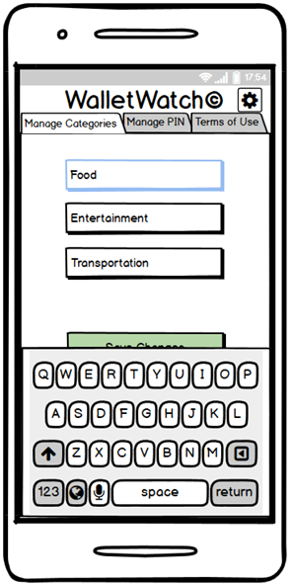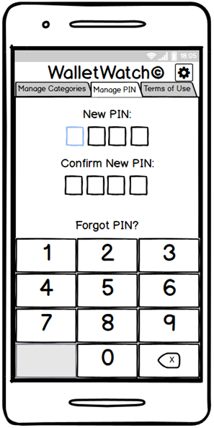

The left screen displays the “Manage Categories” tab, which allows the user to edit the category labels that they would like to track. Tapping the “Save Changes” button will erase all data from any category that was overwritten with a new label. The right screen shows the “Manage PIN” tab, which allows the user to change their PIN or display their PIN upon correctly answering a security question in case they forgot their current PIN. There will also be a “Terms of Use” tab that will explicate the terms and conditions of app usage.

**Data Model**

An example XML file may be viewed here: [WalletWatch.xml](https://spuonline.sharepoint.com/sites/CSC415xWS20202/Shared%20Documents/Team%204/WalletWatch.xml)

The data model will be implemented with a locally-stored encrypted XML file with the following format:

<?xml version="1.0" encoding="UTF-8"?>

<root>

<security>

<pin></pin>

<question>What city were you born in?</question>

<answer></answer>

</security>

<data>

<total>0.00</total>

<category id="1">

<label>Food</label>

<total>0.00</total>

<year id="">

<total>0.00</total>

<month id="">

<total>0.00</total>

<day id="">

<total>0.00</total>

<entry id="1">

<amount>0.00</amount>

<description></description>

</entry>

</day>

</month>

</year>

</category>

<category id="2">

<label>Entertainment</label>

<total>0.00</total>

</category>

<category id="3">

<label>Transportation</label>

<total>0.00</total>

</category>

</data>

</root>